

Engineering Update

Aquarius 01-02

Aquarius²11-12-22

Sagitta 01-02
3011

February 2003

Firmware for Module HM_Link

RHMFV10006

- TABLE OF CONTENTS

- 1. Table of Contents
- 2. Introduction
- 3. Equipment concerned
- 4. Version index
- 5. Enhancements
- 6. Compatibility
- 7. Equipment required
- 8. Step-by-step procedure
- 9. Attached items

- INTRODUCTION

THALES NAVIGATION makes every effort to satisfy its clients by regularly releasing enhanced versions of its products. The object of this document is to provide all the instructions required for updating any equipment already in use in the field so that users can benefit from the new enhancements.

- EQUIPMENT CONCERNED

Product line : Marine
Product : Aquarius01/02-Aquarius²11/12/22-Sagitta 01 / 02 -3011
Sub-part : Module HM_Link.
Firmware : ☑
Software : □
Hardware : □

- VERSION INDEX

RHMFV10006
- ENHANCEMENTS

- HF signal decryption operational.
- Communication improvement with internal PC Board.

- KNOWN ANOMALY

- Impossibility to link two modules HM_Link together.

- COMPATIBILITY

There is no hardware or software incompatibility of any sort with the other parts of the equipment. But to get complete benefit of all improvements, it is advisable to check you receiver hardware/software versions. After completing the update, the different versions in the equipment should be as follows:

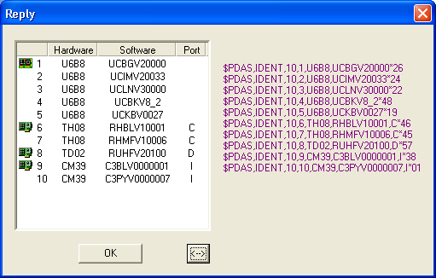

- EQUIPMENT REQUIRED

- A PC computer using WINDOWS95, 98 XP, NT or Millennium
- A PC to receiver serial line cable ( Part No.: 101243A) and RS422/232 converter ( Part No.: 2699075675AC).

- STEP-BY-STEP PROCEDURE

Software and Firmware are available on ftp site. Address ftp://ftp.ashtech.com/

Using Softload.exe software

8.1 Installing SOFTLOAD V2.0 software on your PC’s hard disk.

Run Install-SoftLoad-V2.0.exe and follow instructions.

  - How to UNZIP RHA10006.exe file.

- Copy RHA1006.exe file on your PC.
- Run RHA10006.exe to unzip the file.
- 3 Unzipped files are :

File Name | Date (dd/mm/yy) | Size (bytes)
Thales.def | 06/02/03 | 1 158
TDREHFMF_C.sfl | 17/02/03 | 211
TDREHFMF_D.sfl | 17/02/03 | 211
RHA10006.s | 13/01/03 | 410 528

8.3- Firmware loading

- Copy the Thales.def. file to the “products” directory of Softload.
- Copy the RHA10006.s, TDREHFMF_C.sfl and TDREHFMF_D.sfl files to the “release” directory of Softload.
- Connect A port (RS422) of the receiver to RS232 port of your PC with cable (Part N° ..101243..) and adaptation cable (Part N° ….75675…).
- Switch on the receiver
- Run the SOFTLOAD Software from the task bar ( Start/Programs/ Thales Navigation /SoftLoad)
- If not already done, you must change a parameter in softload.ini file
- Exit from SOFTLOAD software and open the softload.ini file located in Windows directory for Windows95/98/XP or in WinNT for Windows NT/2000
- Modify the line Reserved 3=7 to Reserved 3=15 in [Miscellaneous] block and save the file
- Run again SOFTLOAD Software from the task bar ( Start/Programs/ Thales Navigation /SoftLoad)
- On the File menu, select Open, choose the TDREHFMF_C.sfl or TDREHFMF_D.sfl file if module connected on C or D port, then click Open
- Check data communication between the receiver and the PC by clicking the ? button on the toolbar. If communication is established, a window will open listing the different versions currently installed in the unit. In that case, close this window. If instead of the window, you get an error message, check the connections (data and power cables) and communication parameters. Unless these parameters have intentionally been changed earlier, they usually are the following: 9600 Baud, 8 data bits, 2 stop bits and “no parity”
- To start re-loading, click the red arrow on the toolbar. Note that the time of re-loading is about 2 minutes

NOTICE: At the end of transfer SOFTLOAD software checks to see if the firmware has been correctly loaded then displays the new firmware status
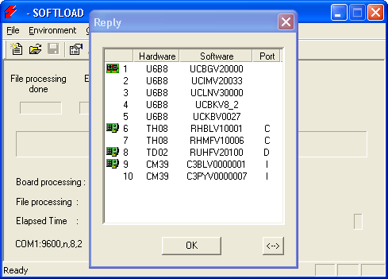

EXIT SoftLoad after loading

RESCUE mode:

If during firmware loading either the receiver or PC supply shuts down it is not any more possible to establish dialogue with HM_Link module.

Set C or D port (with TRM100) at 9600Bds then switch OFF and the receiver.
Check data communication between the receiver and the PC by clicking the ? button on the toolbar.
If communication is established, only boot line is available for HM_Link as « RHBLV10001 ».

Reloading becomes possible.

- ATTACHED ITEMS

Items | Version / name | Date (dd/mm/yy) | Size (bytes)
Logiciel SOFTLOAD | Install-SoftLoad-V2.0.exe | 07/04/02 | 2 658 714
Compressed file RHA10006.exe | RHA10006 | 17/02/03 | 152 064

