

Engineering Update

Aquarius 01-02

Aquarius²11-12-22

Sagitta 01-02
3011

February 2003

Application firmware (PC Board)

UCIMV20037

- TABLE OF CONTENTS

- 1. Table of Contents
- 2. Introduction
- 3. Equipment concerned
- 4. Version index
- 5. Enhancements
- 6. Compatibility
- 7. Equipment required
- 8. Step-by-step procedure
- 9. Attached items

- INTRODUCTION

THALES NAVIGATION makes every effort to satisfy its clients by regularly releasing enhanced versions of its products. The object of this document is to provide all the instructions required for updating any equipment already in use in the field so that users can benefit from the new enhancements.

- EQUIPMENT CONCERNED

Product line : Marine
Product : Aquarius01/02-Aquarius²11/12/22-Sagitta 01 / 02 -3011
Sub-part : PC Board.
Firmware : ☑
Software : □
Hardware : □

- VERSION INDEX

UCIMV20037
- ENHANCEMENTS

- HF decryption operational.
- Improvement of “OPEN” mode.
- Correction of “DGPDAT” output crash after few hours.
- Improvement of routes and Way points.
- Command “ $PDAS,IDPORT “ for port identification..
- Satellites Status on display for secondary antenna.
- Selected output format display on screen.
- Better filtering for raw data.
- Bit Flow in ASCII available.
- Correction for automatic switch OFF of station in RTCM 18 /19

- KNOWN ANOMALY

- Impossibility to link two modules HM_LINK

- COMPATIBILITY

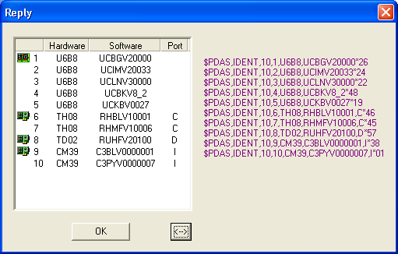
There is no hardware or software incompatibility of any sort with the other parts of the equipment. But to get complete benefit of all improvements, it is advisable to check you receiver hardware/software versions. After completing the update, the different versions in the equipment should be as follows:

NOTICE :

Only CONFIGPACK (version ≥ V3.33) can be used to modify the internal configuration.
Former Confpack used for 5000 and 600 series for this new product line cannot be used

- EQUIPMENT REQUIRED

- A PC computer using WINDOWS95, 98 XP, NT or Millennium
- A PC to receiver serial line cable (Part No.: 101243…) and RS422/232 converter (Part No.: …..75675…).

- STEP-BY-STEP PROCEDURE

Software and Firmware are available on ftp site. Address ftp://ftp.ashtech.com/

Using Softload.exe software

9.1 Installing SOFTLOAD V2.0 software on your PC’s hard disk.

Run Install-SoftLoad-V2.0.exe and follow instructions.

9.2 UNZIP UCIMV20037.EXE file.

- 3 Unzipped files are:

File Name | Date (dd/mm/yy) | Size (bytes)
Thales.def | 06/02/03 | 1158
UCIMV20037.sfl | 06/02/03 | 222
UCIMV20037 | 06/02/03 | 4 119 274

9.3- Firmware loading

- Before loading new firmware, save the configuration file you currently use with CONFIGPACK software.

- Copy the Thales.def file to the “products” directory of Softload.
- Copy the UCIMV20037 (no extension) and UCIMV2003.sfl files to the “release” directory of Softload.
- Connect A port (RS422) of the receiver to RS232 port of your PC with cable (Part N°:.: 101243…) and adaptation cable (Part N°:….75675..).
- Switch on the receiver
- Run the SOFTLOAD Software from the task bar (Start/Programs/ Thales Navigation /SoftLoad)
- If not already done, you must change a parameter in softload.ini file
- Exit from SOFTLOAD software and open the softload.ini file located in Windows directory for Windows95/98/XP or in WinNT for Windows NT/2000
- Modify the line Reserved 3=7 to Reserved 3=15 in [Miscellaneous] block and save the file
- Run again SOFTLOAD Software from the task bar (Start/Programs/ Thales Navigation /SoftLoad)
- On the File menu, select Open, choose the UCIMV20037.sfl file then click Open
- Check data communication between the receiver and the PC by clicking the? button on the toolbar. If communication is established, a window will open listing the different versions currently installed in the unit. In that case, close this window. If instead of the window, you get an error message, check the connections (data and power cables) and communication parameters. Unless these parameters have intentionally been changed earlier, they usually are the following: 9600 Baud, 8 data bits, 2 stop bits and “no parity”
- To start re-loading, click the red arrow on the toolbar. Note that the time of re-loading is about 10 minutes
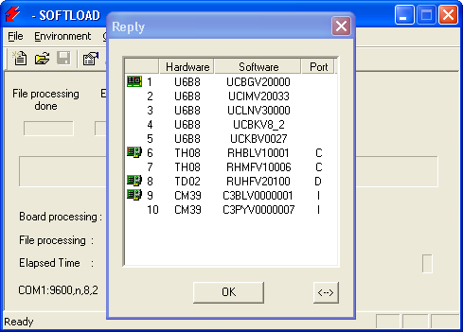

NOTICE: At the end of transfer SOFTLOAD software checks to see if the firmware has been correctly loaded then displays the new firmware status

EXIT SoftLoad after loading

RESCUE mode:

If during firmware loading either the receiver or PC supply shuts down it is not any more possible to establish dialogue.

The “Rescue” mode, selectable in device menu of Softload (selection in Option menu), is used to restore dialogue with the receiver.
Firmware re-loading then becomes possible.

This “Rescue” mode is only available on A port

IMPORTANT WARNING:

- Before using receiver you MUST do as follows
- Open WinCOMM software or any terminal software.
- Send “ $PDAS,CONFIG,DEL ” command.
- Acknowledgement is return by the receiver.
- Make a ON / OFF of the receiver.
- Send “ $PDAS,CONFIG,RESET ” command.
- Be patient while receiver resets its configuration and reboots. This process can take some minutes.

- ATTACHED ITEMS

Items | Version / name | Date (dd/mm/yy) | Size (bytes)
Logiciel SOFTLOAD | Install-SoftLoad-V2.0.exe | 07/04/02 | 2 658 714
Compressed file UCIMV20037.EXE | UCIMV20037 | 17/02/03 | 1 479 680

