

UPGRADE PM700/MM300 FIRMWARE

December 2014

Prerequisites

- Power the GNSS receiver from external power supply to prevent power loss during the upgrade
- Put the GNSS receiver close from the PC to secure the Bluetooth connection and prevent connection loss during the upgrade

Install Spectra Precision Loader on your PC

From the zip file, execute the setup.exe.
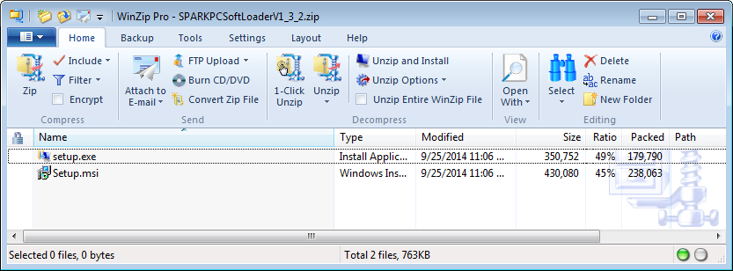
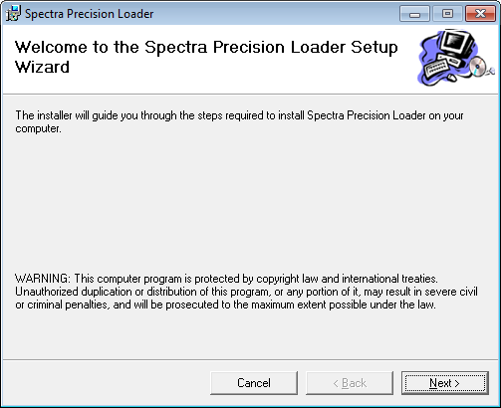
Click “Next”.
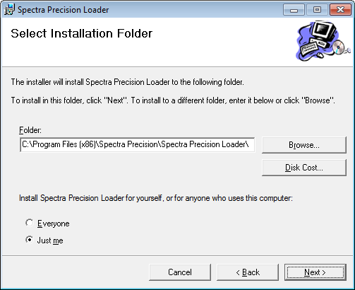
Click “Next”.
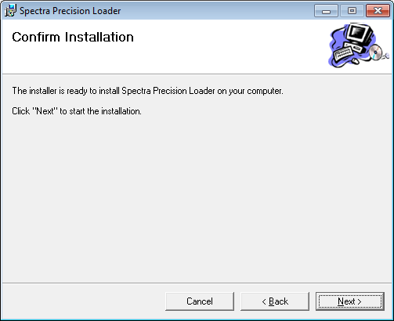
Wait for completion.
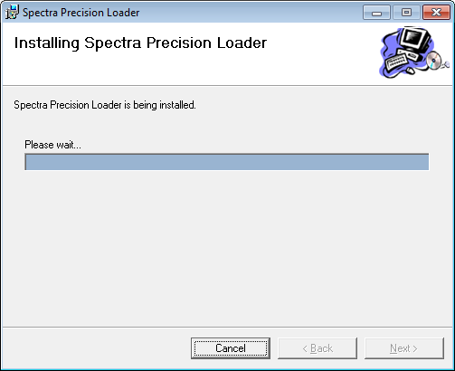
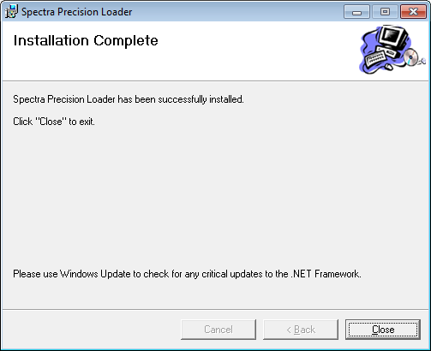
Click « Close ».

Scan Bluetooth devices from the PC

Use a computer with a Bluetooth adapter and scan the neighborhood with the Bluetooth Manager. A button “Search Devices” is most likely available in this tool.
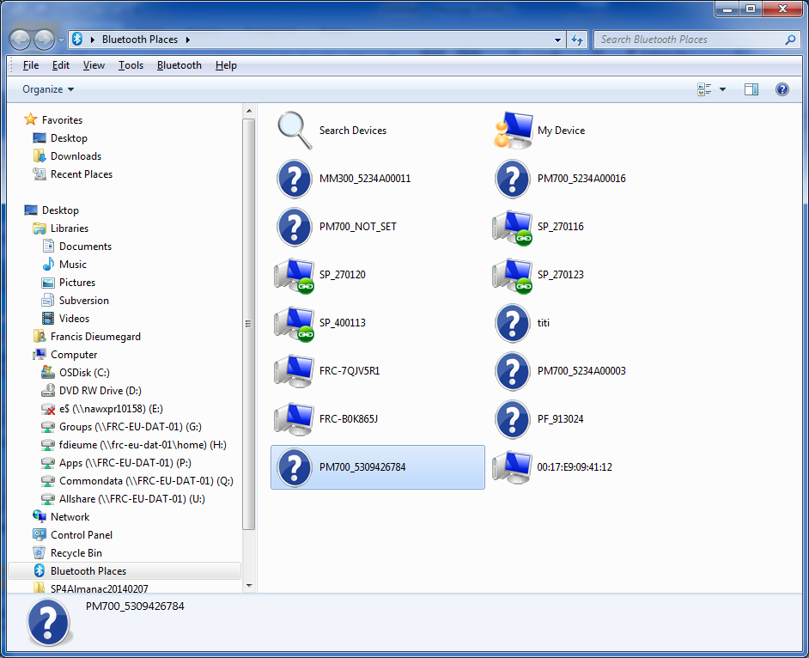

PM700 Bluetooth name starts with « PM700_ » while MM300 name starts with « MM300_ ».
Double-click on the PM700/MM300 BT name ending with the S/N printed on the bottom of your GNSS device. It should display a single service available from your GNSS receiver (i.e. Bluetooth serial port).
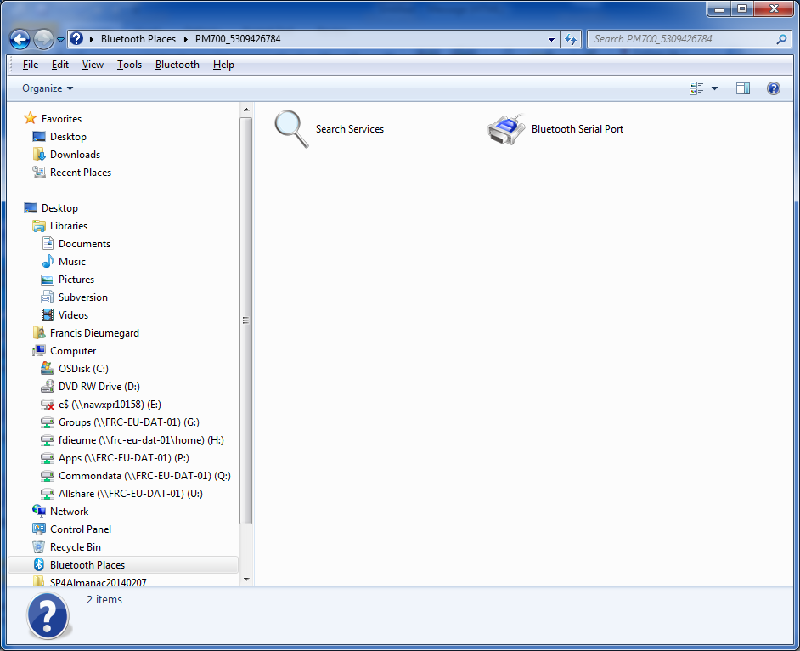
Double-click on the Bluetooth Serial port icon to pair with the GNSS device.
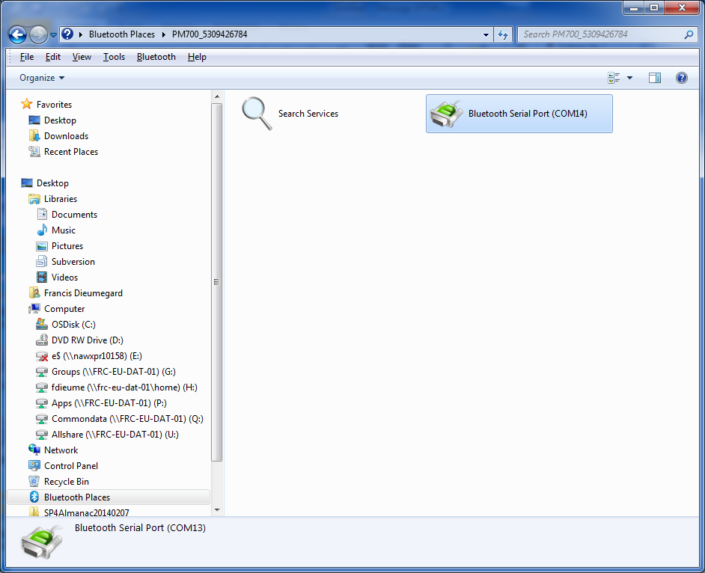
In the example depicted above, the Bluetooth Manager indicates that the PC can communicate with the GNSS receiver over Bluetooth through the port COM14.

Run the Spectra Precision Loader

Start the Spectra Precision Loader and select the COM14.
Browse the directories to select the upgrade BIN file ( V150_V491.bin), and Start the upgrade.
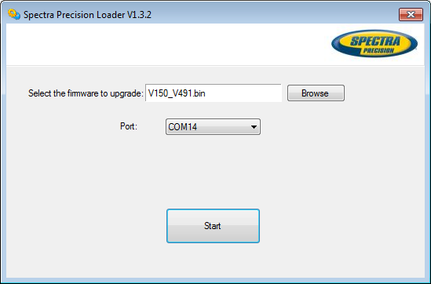

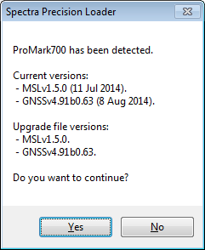

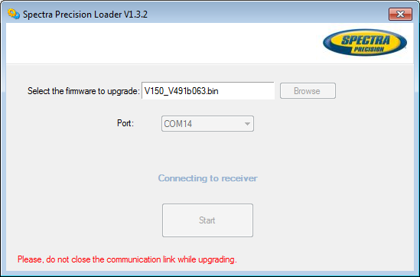
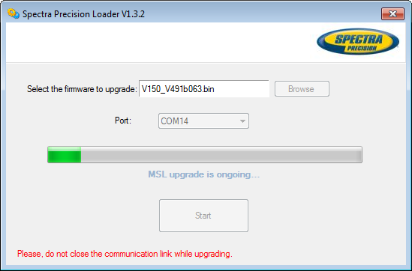
LEDs are OFF.
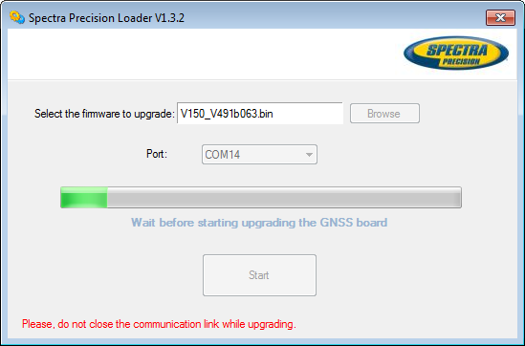
LEDs are blinking.
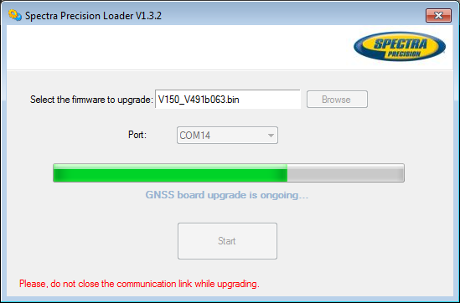
LEDs are OFF.
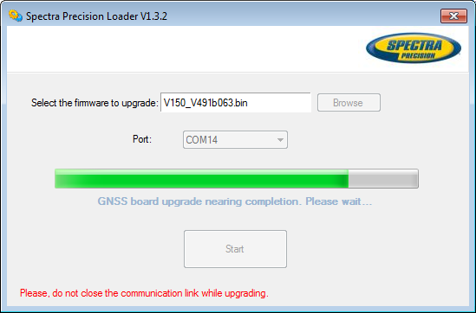
LEDs are blinking green and blue.
