

ProMark 700 / MobileMapper 300
Option Management and Upgrade Procedure

Version 0.3

December 15th, 2014

Ordering a firmware option

A customer can order a firmware option for his ProMark 700 or MobileMapper 300 product in different situations:
- To increase the performance and accuracy of his device
- To extend his warranty period
- To subscribe a to positioning service
Depending of the situation, the customer shall be advised or helped by his dealer to get the desired options.

Increase performance and accuracy of his device

This option is not available for the ProMark 700 receiver while it is for the MobileMapper 300.
For instance, a customer has bought a MobileMapper 300 with the basic accuracy of 30 cm horizontal and 30 cm vertical. He wants to get a better accuracy of 7 cm horizontal and 2 cm vertical. He needs to order the option through his dealer and provide the serial number of his device.
The Option Part numbers available for MobileMapper 300 are presented below:

Part Number | Description
100919-01 | Option 2*7 ACCURACY for MobileMapper 300
100920-01 | Option RTK for MobileMapper 300

The dealer will provide the serial number of the product and the part number of the desired option to the Order Administration (or eventually to the Sales Manager).
Once the payment of the option has been done, the option code is sent to the end customer by the Order Administration officer (see below).
The Spectra Precision Oracle data base is updated with the new option and option code for this customer and this unit S/N.
Example of mail sent by Order Administration.

License Information

Date : November 12, 2014
Serial Number : 5309426734

OPTION 2x7 ACCURACY FOR MobileMapper 300
Part Number : 100919-01
Mode : Permanent

Product Key : C07CE1AE-7BB94B6A-9F5778C7

Extending the warranty period

This option becomes mandatory in the following case:
- Original warranty period of 12 months has expired and the customer wants to extend this period
- A new major version of firmware is available for the product but the customer cannot upgrade because the warranty period has expired.
In these cases, the warranty extension option is managed by Trimble Global Services, which is known as the Technical Support by the dealer.
In this case, the customer shall request a warranty extension to Global Services and provide the serial number of his products.
If Global Services see in the Oracle database that the warranty has expired before the standard period of warranty, a warranty extension can be granted case by case.
If the standard period of warranty or the previous warranty extension has expired, the customer needs to buy a warranty extension option.
Global Services will use Option Generator tool to compute the warranty extension option code and the serial number of the unit.
Once the payment of the option has been done, the option code is cut and paste from Option Generator to an email sent to the end customer by the Global Services officer.

Subscribe to a positioning service

This kind of option is available to customers for the ProMark 700 and MobileMapper 300 receivers through their dealers.
These options are:
- A subscription of 3 months to the CenterPoint RTX correction service
- A subscription of 1 year to the CenterPoint RTX correction service
Once the payment of the subscription has been done by the customer, the dealer connects to the to the Spectra Precision reseller store.
The serial number of the product is entered and the reseller store generates an option code for the customer. It automatically sends an email to the customer with the code to validate the subscription (see below).

The address of the store is https://store.trimble.com

Example of mail sent by Trimble Positioning Services

From: Trimble Services - Europe
Sent: Tuesday, October 14, 2014 11:24 AM
To: R12 Non Prod Emails
Subject: VRSQA - Your subscription activation request

Dear Valued Trimble Partner,

Thank you for your recent request to activate your subscription for the following Trimble CenterPoint RTX service:

DEMO-Continental RangePoint RTX via Satellite
Serial Number: 5309426734

Please follow the appropriate instructions below to complete this action for your subscription, using the following passcode:

5598021A8475E

ACTIVATING YOUR SUBSCRIPTION:
1. Enter the passcode above into your receiver, identified by the serial number shown above.

If you need further assistance with your subscription, please contact us.

Thank you for your business.

Best regards,

Trimble CenterPoint RTX Customer Service Team
Serving Europe, Middle East, Russia, and CIS
Phone: +31 70 317 0911
Fax: +31 70 317 0919
Email: eu_corrections@trimble.com

RECEIVER DETAILS
Serial Number : 5309426734

Industry : GEOSPATIAL - OTHER
Service : DEMO-Continental RangePoint RTX via Satellite Subscription Type :
Start Date : 14-OCT-2014
Expiry Date* : 17-OCT-2014

*Subscription will expire at 00:00:00 UTC time on this date.

CUSTOMER DETAILS
Customer Name : OMNISTAR BV [LEIDSCHENDAM]
Address : IETWEG 17H, Netherlands

Contact Name : Godwin Vincent Telephone : Fax :

Trimble Terms of Subscription : www.trimble.com/TPS_Terms

ADDITIONAL INFORMATION

Installing the option

In any case, the first step for the customer requesting an option is to install the WinFlash configuration tool from the Spectra Precision web site (ProMark 700 or MobileMapper 300 product page, under Support section).

Install the WinFlash configuration tool

Download the self-extractible executable file called WFC-MM300-NoFW.exe.
Double-click to install the executable.
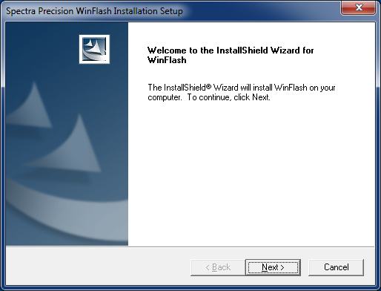
Click the “Next” button.
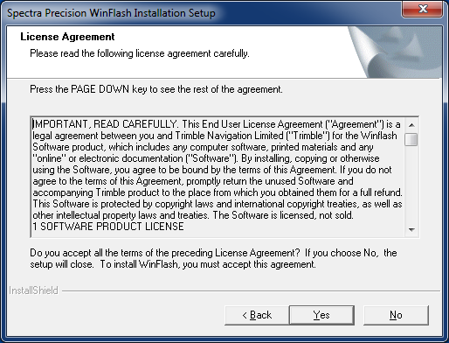
Click “Yes”
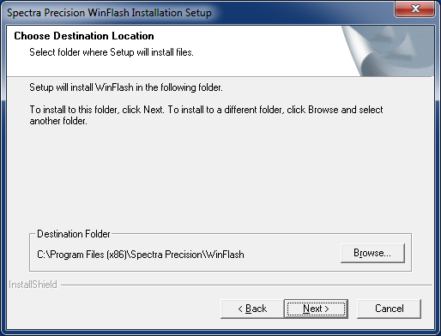
Click the “Next” button if you want to keep the default destination folder.
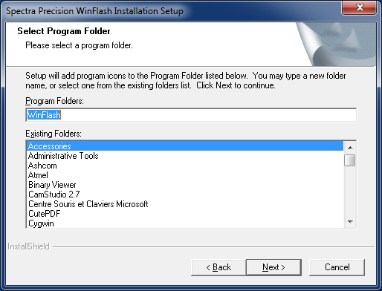
Click the “Next” button.
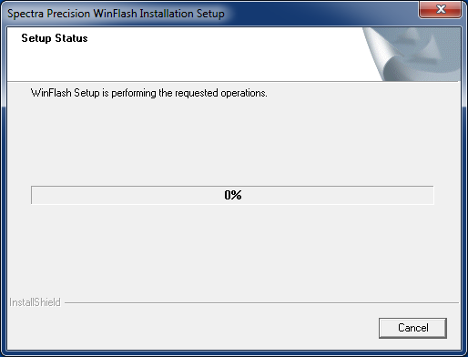
Click on the “Finish” button when the install is complete.
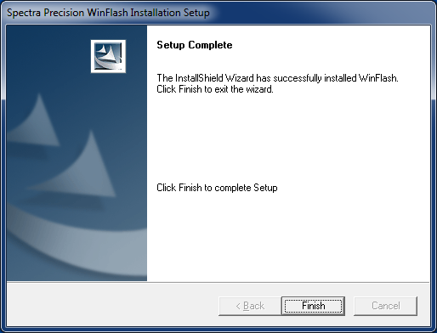

Configuring a Bluetooth serial port

Once the customer gets his option code via the email form, he needs to enter the option code inside the unit using WinFlash.
Because the standard delivery of ProMark 700 / MobileMapper 300 does not include serial cable, the interface between the computer of the customer and the unit shall use Bluetooth.
There will be a variant depending on the operating system of the customer and the Bluetooth adapter used on his computer, but the paradigm remains the same.
After powering on the GNSS receiver, the blue LED indicates, when blinking, that the unit is ready for Bluetooth connection.
Using the Bluetooth Manager of the computer, the unit can be paired over Bluetooth with the following steps:
- Scan the Bluetooth neighborhood
- Select the Bluetooth device name corresponding to the GNSS receiver
- Select the Serial port profile exposed by the GNSS receiver
- Get the name of the COM port that will be used on the computer side
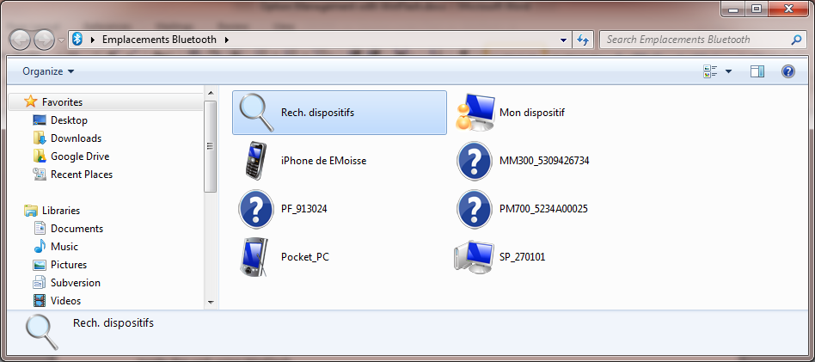
Double-click to see the services available from this device (Serial port)
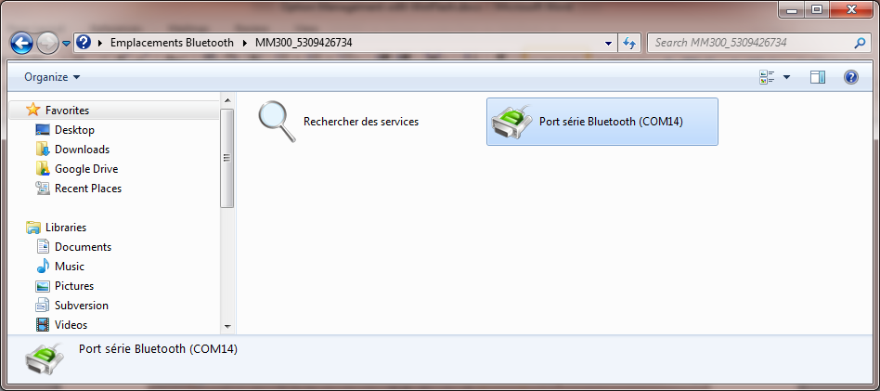
Double-click to pair the device on COM14.

Enter the option code over Bluetooth

- Start WinFlash.
- Select the receiver type: MobileMapper 300 / ProMark 700 Receiver.
- Select the serial port COM14.
- Click the “Next” button

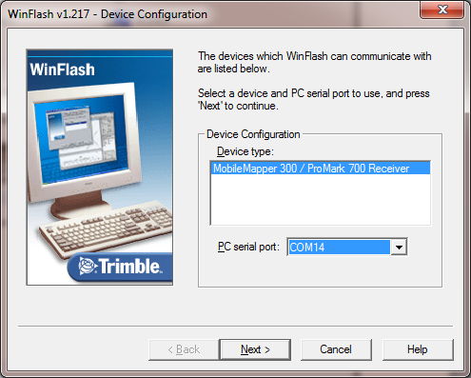

Select “Update receiver options”.
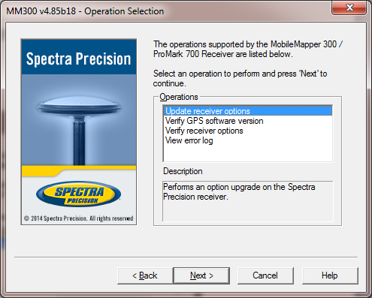
Click the “Next” button.
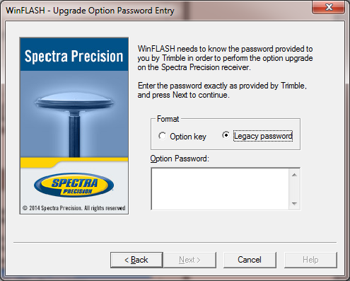

If the option comes from Spectra Precision Order Administration:
- Select the “Legacy password” radio button.
- Paste the Option password provided via the email form.
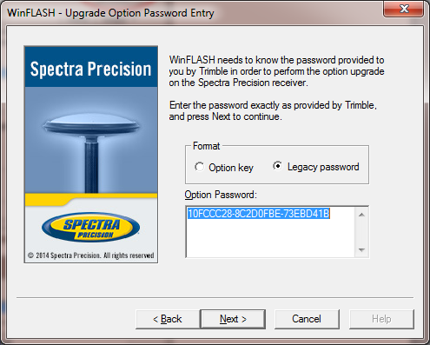
If the option comes from Trimble Positioning Services (RTX subscription) or Spectra Precision Technical Support (Warranty extension):
- Select the “Option key” radio button.
- Paste the Option password provided via the email form.
Click the “Next” button.
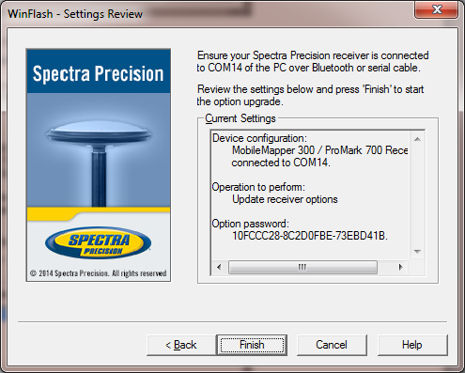
Click the “Finish” button.
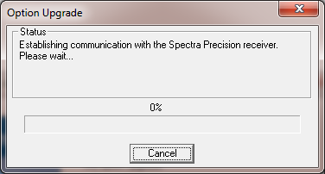
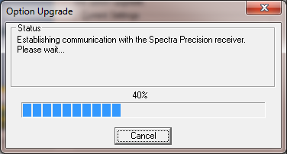
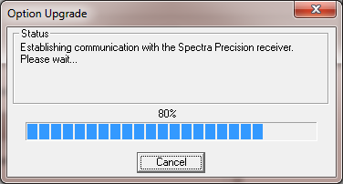
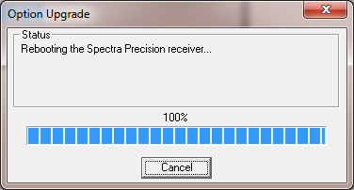
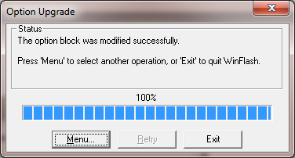
The operation is successful.
Click the “Exit” button.
