Multipath Mitigation
Overview
Multipath occurs when GPS signals arrive at the receiver after being reflected off some object. The reflected signals always travel a longer path length than the direct signal. This leads to measurement errors in the receiver that is trying to measure the direct path length to the satellite. The techniques for rejecting the reflected signals are known as multipath mitigation.
The G12 and DG16 family implements one type of correlator for multipath mitigation: Edge Correlator™.
This correlator improves multipath mitigation over the traditional correlator schemes with standard (1-chip) correlator spacing and narrow (1/10 chip) correlator spacing.
The Edge Correlator is standard with all products from the G12, DG and GG families. The performance of an Edge correlator is slightly better than a narrow correlator with 1/10 chip spacing. The Strobe correlator (patent pending) implements a significantly different scheme than any prior multipath mitigation scheme.

Evaluating Correlator Performance
Theoretical analysis of the different multipath mitigation techniques is a straight forward analysis of how much error hypothetical multipath signals would cause. A plot of multipath mitigation performance is made by assuming a reflected signal with a certain power (usually half the power of the direct signal) and a certain delay. The induced error on the range measurement is then calculated and plotted. Figure 1 shows the errors induced by a multipath signal half the strength of the direct signal. The x-axis shows the multipath delay, which is the extra distance that the reflected signal travels compared to the direct signal. The y-axis shows the induced range error caused by a multipath signal with the indicated delay.
From this figure, you can see that typical narrow correlator performance and Edge Correlator performance are similar, while Strobe correlator performance is much better, almost totally canceling any multipath with a delay of more than 37m. .
In a real situation, multipath is usually a combination of many reflections, all with different delays and different power. Real-life multipath is often described as either close in multipath or far multipath. Close-in multipath occurs when the reflecting surface is close to the satellite antenna direct line, and the delay is small; usually, these reflections come from a surface near the antenna, for example, an antenna on a tripod on the ground would pick up close-in multipath from reflections off the ground below and around the tripod. Choke-ring antennas are probably the best cure for close-in multipath. Correlator based multipath techniques, as shown in Figure 1, are all bad at rejecting very close-in multipath mitigation.
Very close-in multipath causes only a small change in the ideal correlation function, so it is almost impossible for the correlator-base multipath integration to determine the error. Far multipath can cause very large errors if a good multipath mitigation technique is not used.
Far multipath occurs when there is a reflecting surface at some distance from the antenna, such as a building, a mast, a mountain, etc. Metal surfaces cause the strongest reflections. Far multipath signals can be very nearly eliminated by good correlator-based multipath mitigation techniques. In an environment where there is a lot of far multipath, Strobe Correlation will be as good as or better than a choke ring.
The bottom line on multipath mitigation is that the errors, or lack or errors, are seen in the position accuracy.
Figure 1: Relative Performance of Multipath Mitigation Techniques
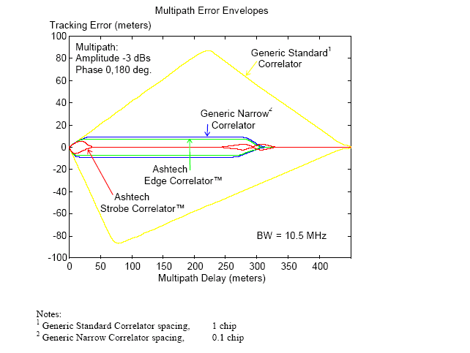

Figure 1: Relative Performance of Multipath Mitigation Techniques

Very close-in multipath causes only a small change in the ideal correlation function, so it is almost impossible for the correlator-base multipath integration to determine the error. Far multipath can cause very large errors if a good multipath mitigation technique is not used.
Far multipath occurs when there is a reflecting surface at some distance from the antenna, such as a building, a mast, a mountain, etc. Metal surfaces cause the strongest reflections. Far multipath signals can be very nearly eliminated by good correlator-based multipath mitigation techniques. In an environment where there is a lot of far multipath, Strobe Correlation will be as good as or better than a choke ring.
The bottom line on multipath mitigation is that the errors, or lack or errors, are seen in the position accuracy.
Multipath Mitigation
[1] “ Strobe & Edge Correlator Multipath Mitigation for Code”, Lionel Garin, Frank
van Diggelen, Jean-Michel Rousseau, Proceedings of ION-GPS’96, Sept. 17-19
1996, Kansas City, Missouri
[2] “The Ashtech GG Family of Products”, Frank van Diggelen. Proceedings on IONGPS’
96, Sept. 17-19 1996, Kansas City, Missouri

